Naming convention for Azure VM

**Environment-Region- Service/Role- Instance/Number** > dev-EASTUS-VM-01

* **Environment**: Identify the environment where the VM is deployed (e.g., prod, dev, test, stg).
* **Region**: Indicate the Azure region (e.g., useast, westeurope, eastasia).
* **Service/Role**: Describe the primary service or role of the VM (e.g., web, db, app, proxy).
* **Instance/Number**: Include a unique identifier or number for the VM instance (e.g., 01, 02).

Example:

* prod-useast-web-01
* dev-westeurope-db-02
* test-eastasia-app-03

Creating a virtual machine

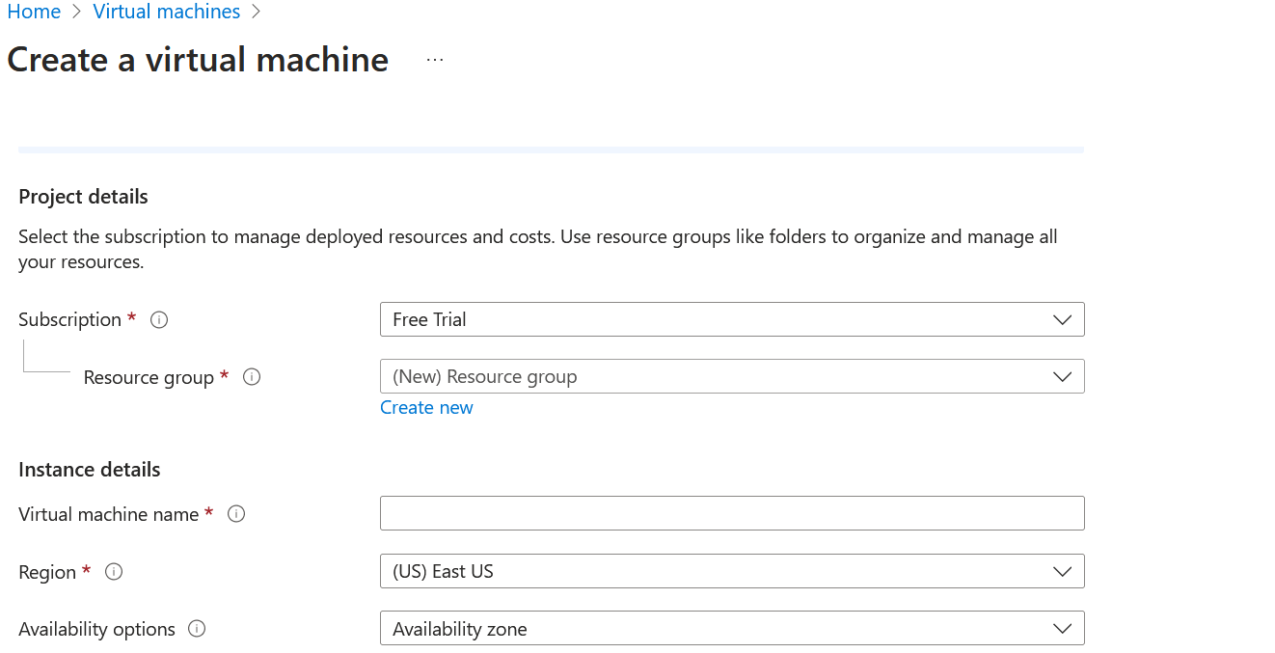

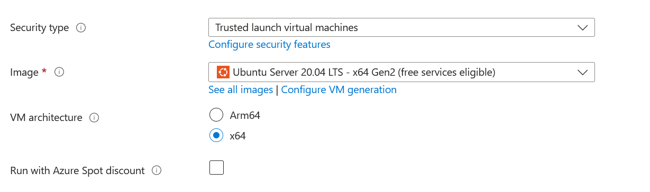

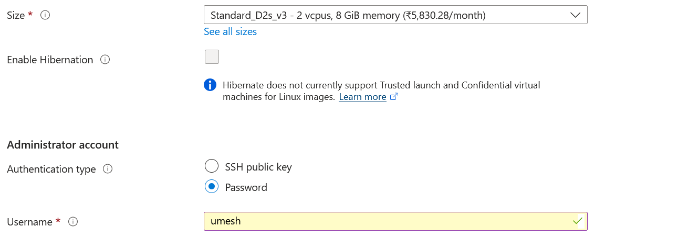

Rule for password:

